Department of Computer Science and Engineering

Amrita School of Computing, Coimbatore

Amrita Vishwa Vidyapeetham – India

19CSE446 – Internet of Things

2024-25 Even Sem

Course Project Details

Title of the Project:

Smart Package Retrieval System

|  |  |  |  |
| --- | --- | --- | --- |
| S. No. | Roll No | Name | WhatsApp No. |
| 1. | CB.EN.U4CSE22351 | Santanu Jha | 9142090989 |
| 2. | CB.EN.U4CSE22012 | Daniyal Ahmad | 7903935404 |
| 3. | CB.EN.U4CSE22511 | Ehtesham Ali Haidar | 8434515330 |

1. **Problem Statement and Literature Survey**

* **Understanding of the problem statement**: -
  + - Manual package retrieval in storage systems is often slow and error-prone. To solve this, the **Smart Package Retrieval System** uses an ***RFID-based user identification*** and a ***motorized 2D shaft mechanism***. When a user scans their ***RFID card*** using an ***EM-18* *scanner module***, the system locates the user’s package and automatically moves to the correct shelf. The shaft then **pushes the package out**, allowing quick and accurate retrieval without human assistance.
* **Literature survey**: -
  + **Previous works**: -
    - Early implementations of AS/RS used barcode-based systems combined with conveyor belts or robotic arms. Research in the 2000s focused on improving pick-and-place accuracy using PLCs and sensors.
    - CNC and robotic XY plotter mechanisms have been used in industrial and academic settings to achieve precise positioning. These systems inspired automation in product dispensing and pick-and-place operations.
* **Current scenario**: -
  + **International Level**:  
    Companies like ***Amazon Robotics*** and ***Alibaba Cainiao*** are leading the way in warehouse automation using robotics, AI, and RFID for real-time tracking and retrieval.
  + **National Level (India)**:  
    Indian startups and government-backed smart city initiatives are integrating RFID and IoT in logistics and public distribution systems.

**2.Proposed solution (description)**

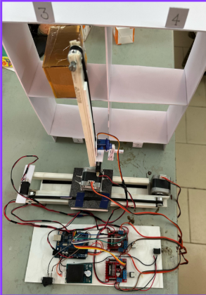

(Reference image)

* To address the inefficiencies of manual package retrieval in storage systems, we propose a Smart Package Retrieval System that combines RFID-based user identification with an automated 2D shaft mechanism.
* In this system, each user is given an ***RFID* card** linked to their stored package. When the user scans the card using an ***EM-18 RFID scanner***, the system identifies the exact shelf where the package is stored.
* A ***motorized shaft*** that can move in both horizontal and vertical directions is then activated. This shaft navigates to the correct shelf and ***gently pushes the package* out**, making it easily accessible for the user.
* This solution reduces human effort, minimizes errors, and speeds up the retrieval process. The system is especially useful in ***smart lockers*, *storage hubs*, or *institutional parcel systems***, where quick and secure retrieval is important.

**3.IoT Level 5 diagram for the proposed solution**

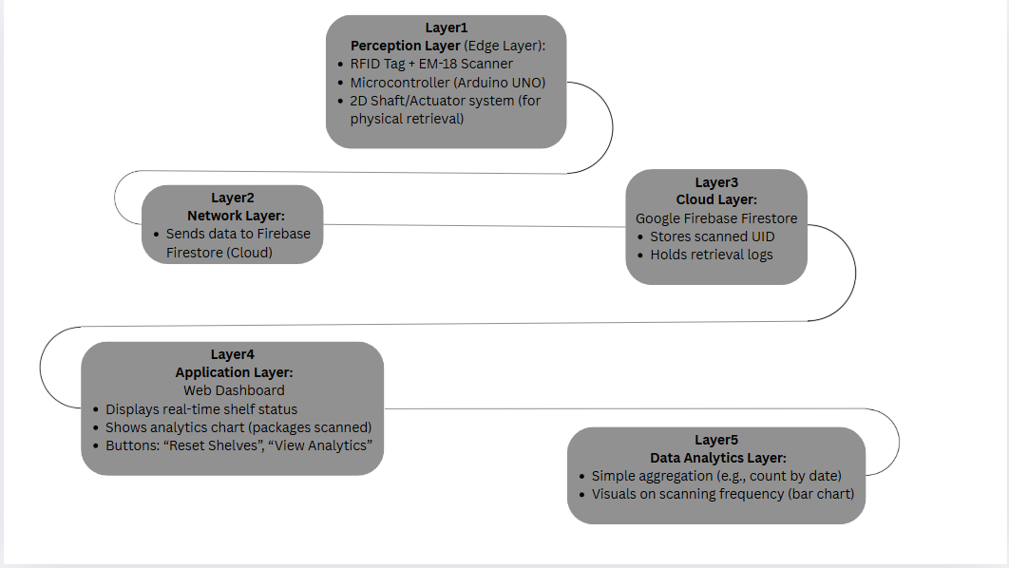

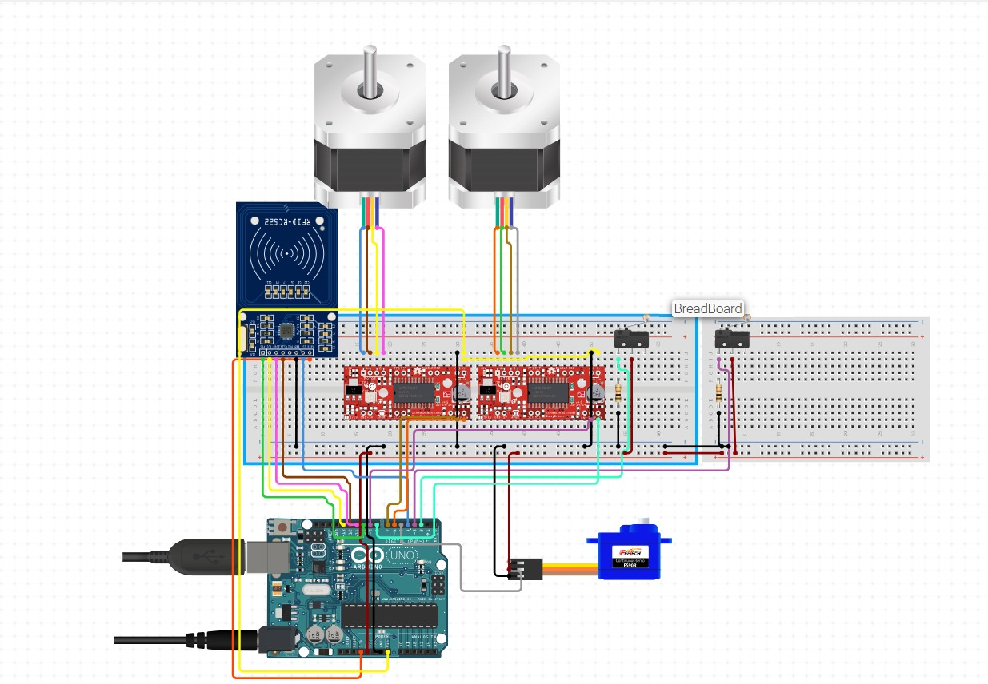 (Circuit Diagram)

**4.List Sensors, Actuators, End, Edge and Cloud details**

|  |  |  |
| --- | --- | --- |
| S. No. | Name of the components | Quantity |
| 1. | Arduino Uno | 1 |
| 2. | Nema-17 stepper motors | 2 |
| 3. | L298n motor driver | 2 |
| 4. | EM-18 RFID Module | 1 |
| 5. | RFID Tag | 4 |
| 6. | Switch | 1 |
| 7. | Limit Switch | 2 |
| 8. | Firebase Cloud Database | - |
| 9. | Servo Motor(9g) | 1 |
| 10. | JIO Power adapter (2.5 A) | 1 |

|  |  |  |
| --- | --- | --- |
| S. No. | Name of the hardware components | Quantity |
| 1. | Timing belt(6mm) | 2m |
| 2. | Pulley (6mm bore) | 2 |
| 3. | PVC electrical pipes | 1m |
| 4. | Connecting wires | As per requirement |

**5. Identification of things**

* In the Smart Package Retrieval System, ***identification of users and their corresponding packages*** is achieved using ***RFID (Radio Frequency Identification)*** technology.
* Each user is assigned a **unique RFID card** that contains a digital identification number (UID). These cards are read using the **EM-18 RFID Reader**, which scans the tag and sends the UID to the microcontroller.
* The system uses this UID to:
* Authenticate the user
* Retrieve the corresponding package's location from a pre-defined mapping
* Trigger the 2D shaft mechanism to move to the correct shelf
* This method of identification ensures:
* **Contactless and quick recognition** of users
* **Error-free mapping** between users and their packages
* Enhanced **security and automation** since only authorized RFID tags are recognized

**6.End node design (Hardware and Software)**

* An **end node** is the device that directly senses or interacts with the environment.
* **Hardware:**
* **EM-18 RFID Reader** – reads RFID cards.
* **RFID Tag/Card** – unique ID for each user/package.
* **Microcontroller (Arduino UNO)** – controls the logic, reads tag ID, and sends it to the cloud.
* **Software:**
* Code written in **Arduino IDE (for Arduino UNO)**.
* Sends scanned RFID UID to Firebase (via the backend server).
* Handles shaft motor activation (2D axis movement) for package retrieval.

**7. Edge node design (Hardware and Software)**

* An **edge node** processes the data locally or semi-locally, before sending it to the cloud.
* **Hardware:**
* **Arduino Uno (**acting as both end and edge node**)**
* **Motor Drivers, Stepper motors** for 2D shaft movement
* **Power Supply & Relay Modules**
* **Software:**
* Runs logic to match UID with shelf
* Controls motor to move to correct shelf
* Triggers actuator to push package
* Optionally sends retrieval status to cloud

**8.Need for Cloud and implementation of its services in the proposed solution**

* In the Smart Package Retrieval System, cloud computing plays a key role in, ***centralized storage***, and ***communication*** betweenthe ***hardware system*** and the ***user interface (UI)***.
* Why Cloud is Needed: -
* To store user scan data
* To bridge communication between edge devices (microcontroller) and the web application
* To enable real-time updates on the UI when a card is scanned or a package is retrieved
* To maintain a history or log of retrievals for future analysis
* Utilization of cloud data storage in the Proposed Solution: -
  + When a user scans their ***RFID tag***, the microcontroller reads the UID and sends this data to ***Firebase***
  + The **web interface** continuously listens to ***Firebase*** updates and, upon receiving a new scan entry, highlightsthe correct shelf in the UI

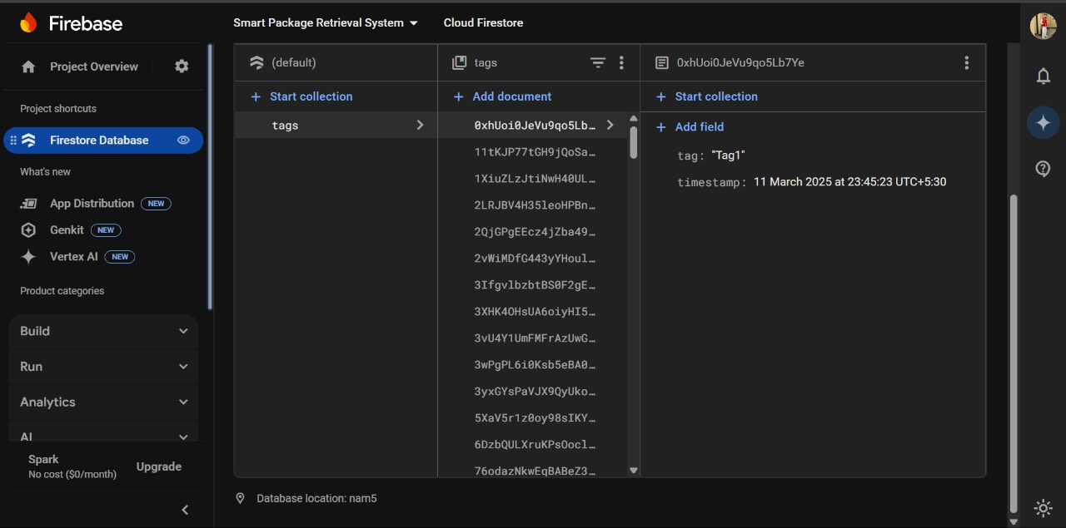

(reference image)

**9.Integration of Intelligence at Edge and cloud**

* To enhance the automation and decision-making capabilities of the Smart Package Retrieval System, the architecture is designed with integration of intelligence — both at the **edge node** and on the **cloud platform**.
* **Edge Intelligence**
* The system can be enhanced with basic decision-making logic on the edge device.
* based on historical scan frequency, the shaft can pre-position itself near high-demand shelves to reduce retrieval time.
* It can also detect unusual scanning behaviour (e.g., multiple failed scans) and trigger alerts for potential misuse.
* **Cloud Intelligence (Using Firestore Data)**
* The UI already collects scan data and stores it in Firestore.
* This data can be analysed to identify peak usage hours and shelf usage distribution.

**10.IoT Analytics and UI Layout**

* UI Layout: -

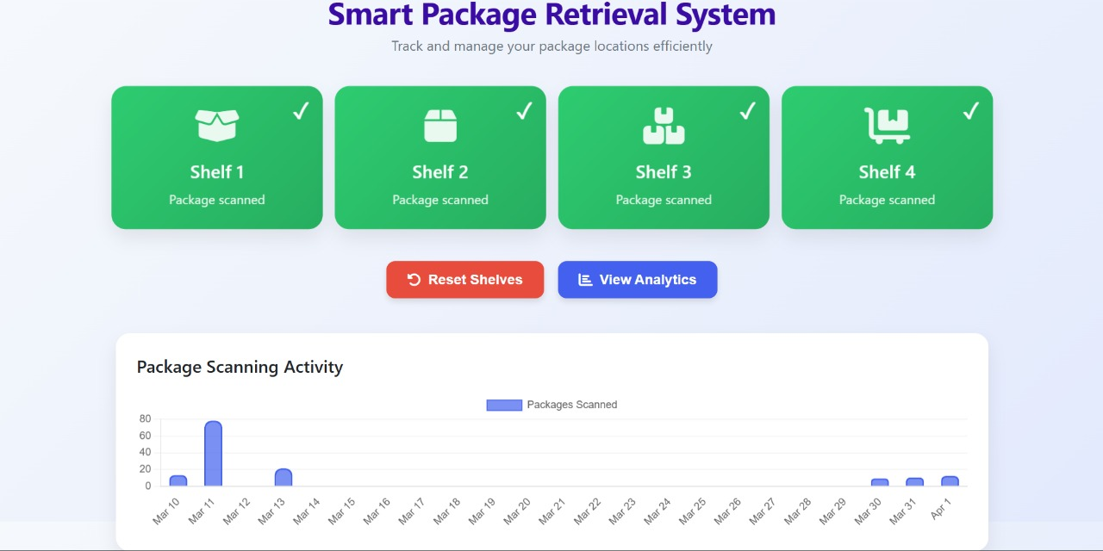

**1. Real-Time Shelf Status Display: -**

At the top of the page, there are **four shelf indicators** (Shelf 1, Shelf 2, Shelf 3, and Shelf 4), each showing the current status of package retrieval:

* When a user ***scans an RFID tag***, the UID is sent to Firebase.
* Based on the UID-to-shelf mapping, the corresponding shelf boxon the UI ***gets highlighted*** in green with a tick mark and status "Package scanned".
* This helps users and operators quickly identify which shelf contains the ***active or retrieved package***.
  + The **“Reset Shelves”** button allows the system to ***clear all statuses*** and return the interface to its default state after a retrieval session.

**2. Package Scanning Activity (Data Analytics)**

Below the shelf section, there is a **bar graph** titled **"Package Scanning Activity"**, showing the **number of packages scanned per day** over a time period when the “View Analytics” button is pressed:

* This data is fetched from **Firebase’s historical records** of RFID scans.
* The graph helps analyse **daily trends**, such as peak usage times or days with unusually high activity.